NO …………..,……….,…………… Class……………………….. Sheet extra 1
Change the adjective to adverb.
- Ajan Poo is more serious than Ajan Nok.

______________________________________
- Ajan Poo is more careful than Ajan Nok.

_____________________________________________________
- Ajan Poo is neat than Ajan Nok.

_____________________________________________________
- Ajan Poo is careful than Ajan Nok.

______________________________________________________
- Ajan Poo is more beautiful than Ajan Nok.

_______________________________________________________
- Ajan Poo is sweeter than Ajan Nok.

_______________________________________________________

A subway train can get you through the city more quickly than a bus.
("more quickly" describes the verb "get." "Get" is a verb.)

A laptop computer allows her to do her work more efficiently.

Barack Obama campaigned more skillfully than his opponents, and that's one reason why he won his election.
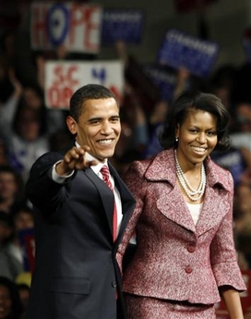

Some adverbs have only one syllable and don't add "ly."
fast, hard, soon, high
- She works faster than he does.
- He can reach higher than she can.
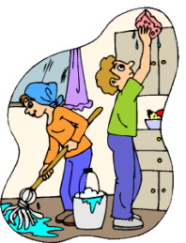
- They'll finish their work sooner than they did last week

CAREFUL, STUPID, GOOD, EARLY, HARD, FAST, COMFORTABLE, SLOW, SOON, QUICK
1 You will get there _____________________ if you take the train.
2. You can travel _____________________ in First Class.
3. I speak English _____________________ than you.
4. Can’t you drive ______________________ ? We’re going to be late!
5. The students in this class work ____________________ than my old class.
6. He reads ____________________ than me. It takes him a long time to finish a book.
7. They arrived much _____________________ than we expected.
8. You should drive _____________________ at night than during the day.
9. He recovered much _____________________ than the doctors expected.
10. He’s behaving even _____________________ than yesterday
……………………………………………………………………

- Jeff works more quietly than Steve does.
- Jeff works the most quietly of all the students.
- Mary drives more carefully than John does.
- Of the three drivers, Mary drives the most carefully.
- Steve works more happily than he used to.
- Mary sings the most happily of all the girls in the group.

………………………………………………………………………………………..
- Please work harder.
- Steve works the hardest.
- Mary runs faster than John does.
- Mary runs the fastest of all the runners on the team.
- Steve gets to work earlier than I do.
- Steve gets to work the earliest of all.
- …………………………………………..

- John plays tennis better than Jack does.
- On our tennis team, John plays tennis the best.
- I did worse on the test than Bart did.
- On that test, I did the worst in the class.
- My paper airplane flew farther than yours did.
- My paper airplane flew the farthest of all.

Complete the sentences by changing the words in brackets ( ) into superlative adverbs.
5 items remaining
1.
I'll go and buy the train tickets. I live
(near) to the station.
2.
Nowadays I
(often) buy books online. It's cheaper.
3.
You can contact me
(easy) by email. Here's my address.
4.
Edwards finished the race by far
(fast), with a time of just 14.8 seconds.
5.
In the chemistry exam, Kate did much
(bad) of all the students. She only got 34 per cent.
6.
Although my team easily played
(good), they didn't win the tournament.

……………………………………………………………….

Write down the correct form of the word in brackets (adjective or adverb).
- Tom is slow. He works slowly .
- Sue is a careful girl. She climbed up the ladder carefully .
- The dog is angry. It barks angrily .
- He acted excellently. He's an excellent actor.
- They learn English easily. They think English is an easy language.
- Max is a good singer. He sings well .
- It's awfully cold today. The cold wind is awful .
- Dogs rely on their noses as they can smell extremely well. If that is true, why does dog food smell so terrible ?
- The little boy looked sad. I went over to comfort him and he looked at me sadly .
- I tasted the soup carefully but it tasted wonderful .

