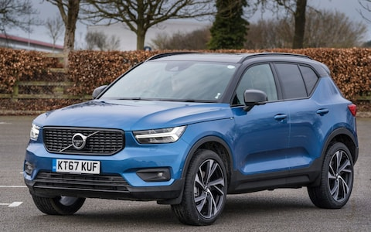
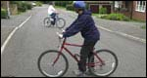

1

- The bike is …………………………………………………………………………………..

- The ……………………………………………………………………………………………….

- CD (compact disc) is ……………………………………………………………………………………..

- ……………………………………………………………………………………………………………………………

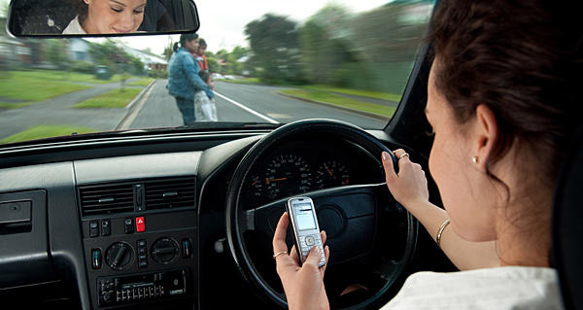

Her name is Susan

Her name is Mary
- …………………………………………………………………………………………………………………………

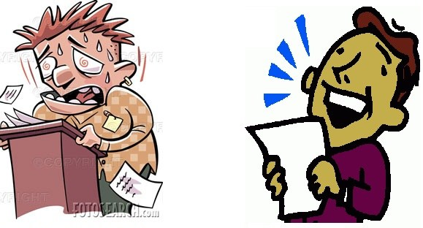

last year this year
4.My boss, Mr Harry Jones, speaks……………………………………………………………………………….

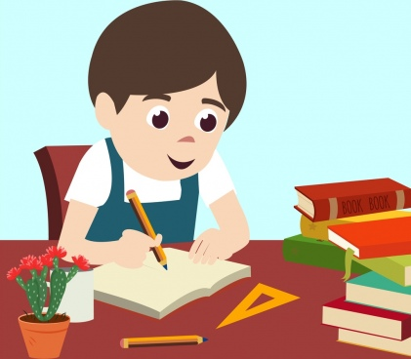
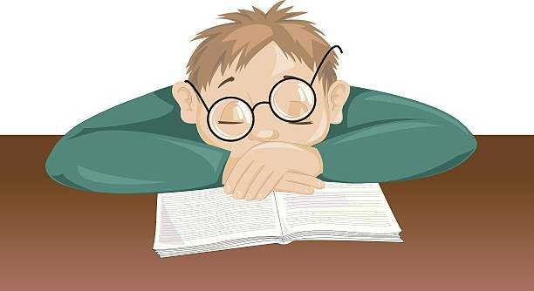

My elder brother My younger brother
5.…………………………………………………………………………………………………………………………..

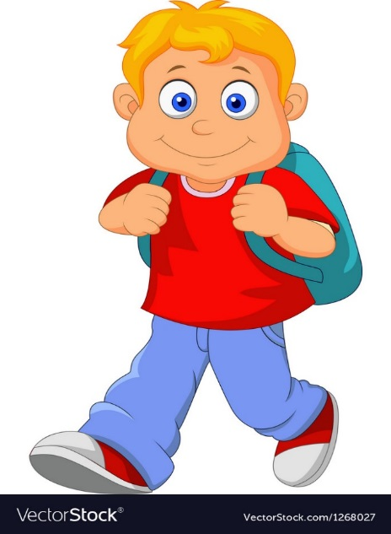
The boy comes to school at 7.00 a.m. The girl comes to school almost 8.00 a.m.
6……………………………………………………………………………………………………………………………..

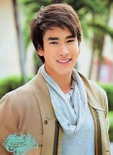

Nadet his friend

7. ………………………………………………………………………………………………………………………………………….

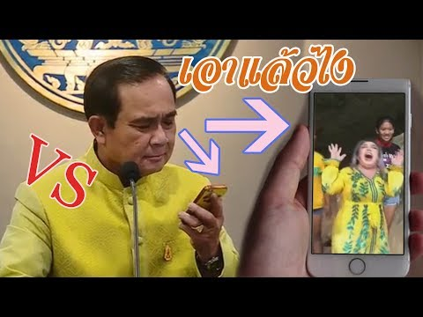
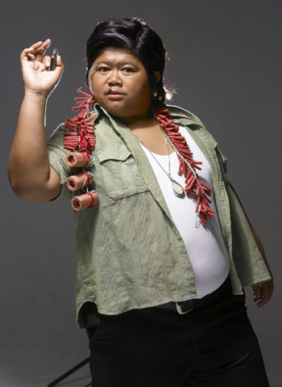

8. The Prime minister speaks …………………………………………………………………………………………………………

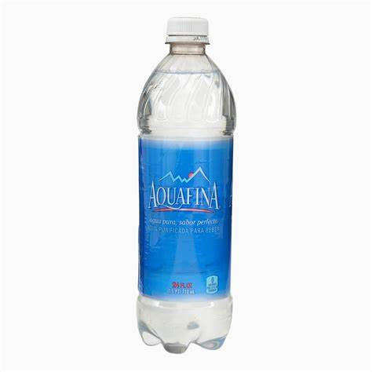
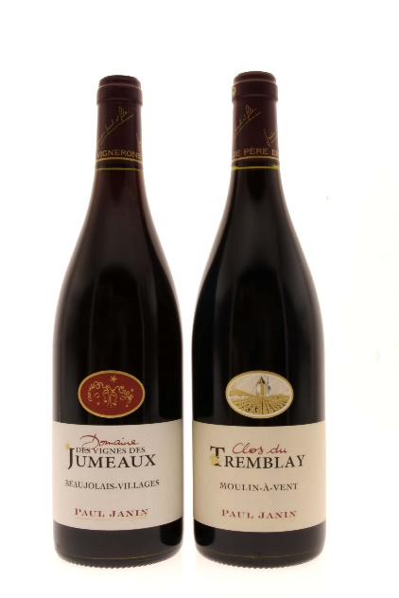

wine water beer
9.The water is ……………………………………………………………………………
9. Beer is ……………………………………………………………………………………

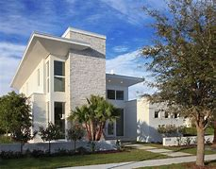
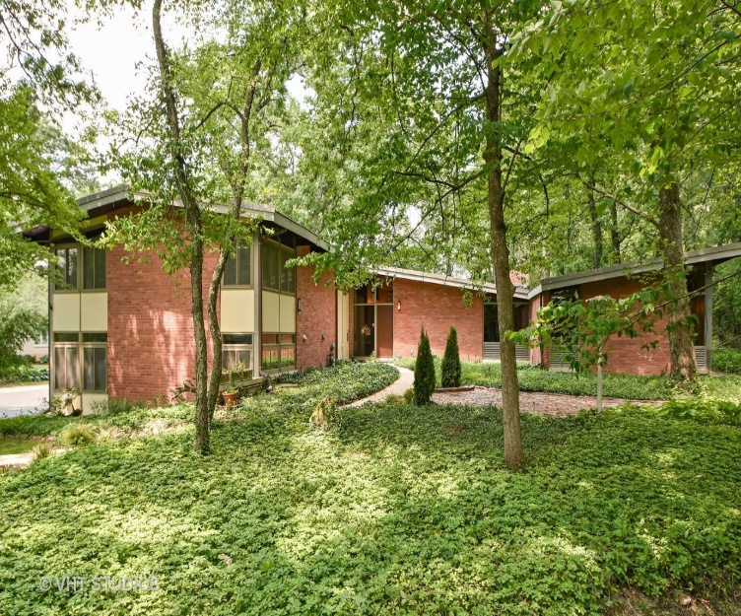

Ajan Nok’s house Ajan Tee’s house
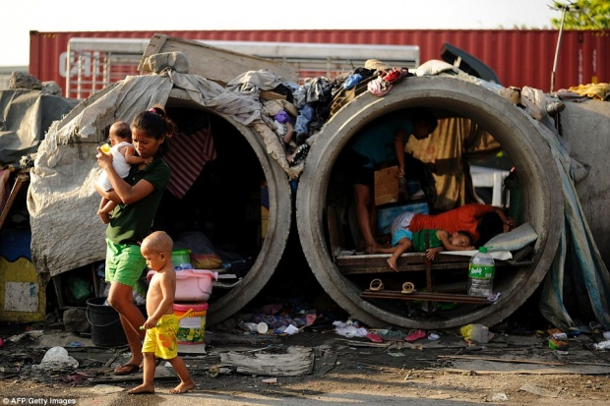

Ajan Pu’s house

10. .Ajan Nok’s house is …………………………………………………………………….
10. Ajan Tee’s house is …………………………………………………………… Ajan Pu’s house

People in the past

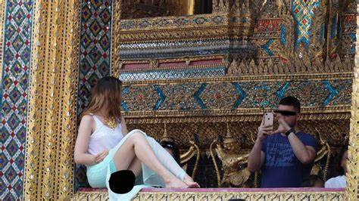

People today
11. People in the past are …………………………………………………………………….
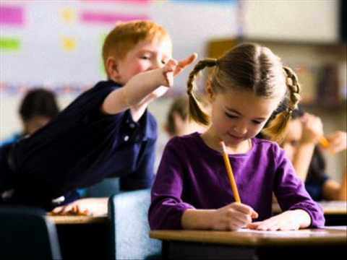

12. The boy behaves……………………………………..

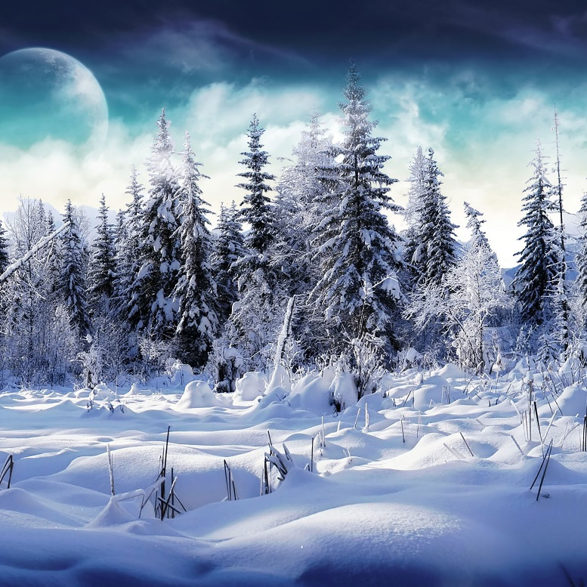

this month

last month

13. This month the weather ……………………………………………………………………………

UNIT 5 Possession
NO………..,…………and…………., Class……………
Write the sentences by following the pictures.

1.______________________________________________________

2.______________________________________________________

3.______________________________________________________

4.______________________________________________________

5.______________________________________________________

6.______________________________________________________

7.______________________________________________________

8.______________________________________________________

9.______________________________________________________

10.______________________________________________________

11.______________________________________________________

