1. What is it?
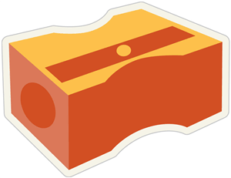
a. It is a pencil case. b. It is a globe.
c. It is a pencil sharpener. d. It is a correction pen.

2. What is it?
a. It is a whiteboard. b. It is an eraser.
c. It is a microscope. d. It is a compass.

3. What school object is it?
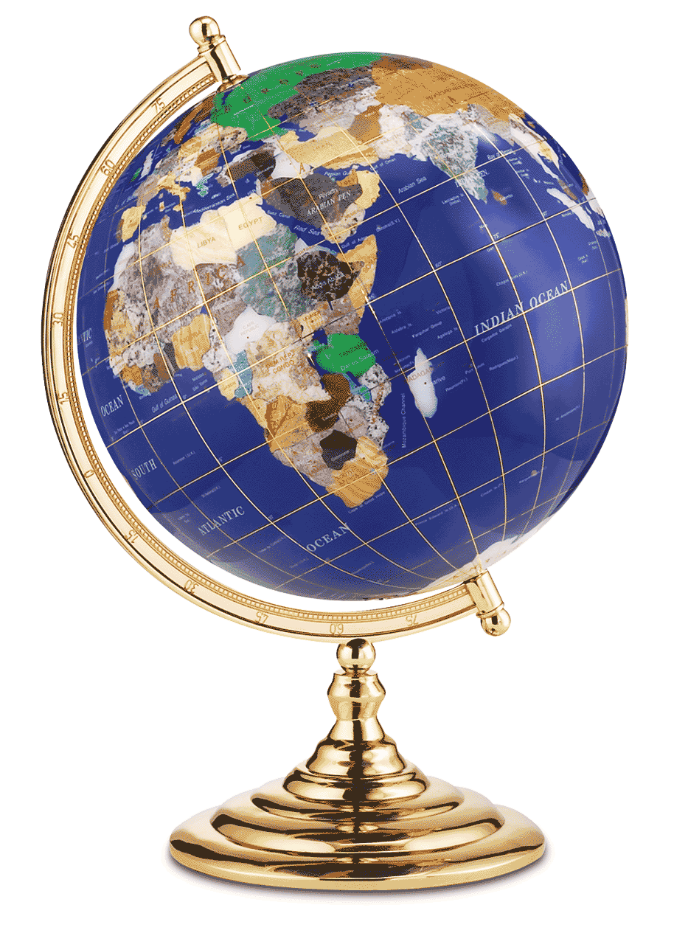
a. a book b. a globe
c. an atlas d. a whiteboard

4. What is this object for?
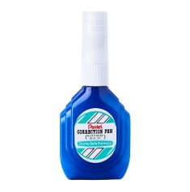
a. This is a correction pen.
b. This is for correcting the error texts.
c. This is a microscope.
d. This is for looking at too small things.

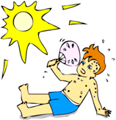
5. What’s the weather like today?
A. It’s hot. B. It’s dry.
C. It’s windy. D. It’s mild.

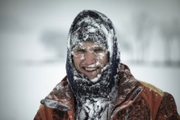
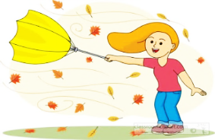
6. What’s the weather like today?
A. It’s foggy. B. It’s mild.
C. It’s stormy. D. It’s freezing.

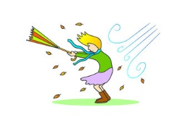
7. What’s the weather like today?
A. It’s cloudy. B. It’s cold.
C. It’s rainy. D. It’s windy.

8. You wear this in summer, it is a_______.
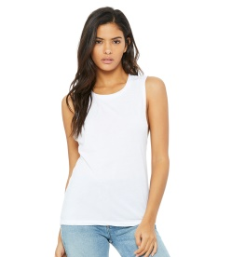
A. It’s a coat. B. It’s a tank top.
C. It’s a sweater. D. It’s a rainy coat.

9. You wear this in winter, it is a_______.
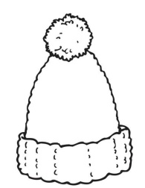
A. It’s a cap. B. It’s a scarf.
C. It’s a woolen hat. D. It’s an earmuff.

