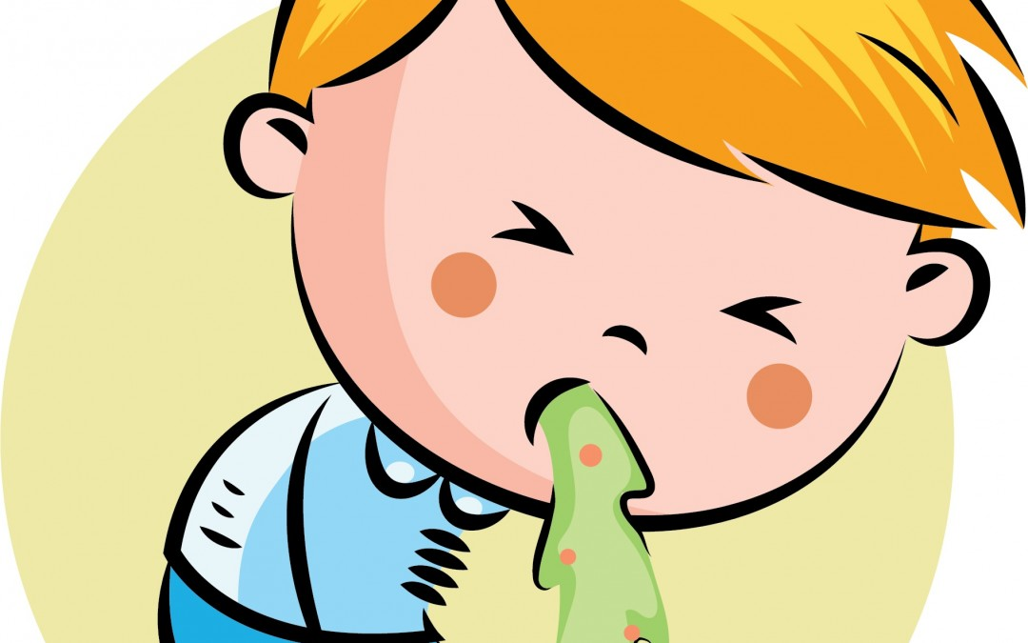













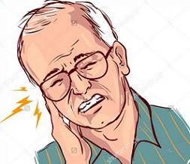







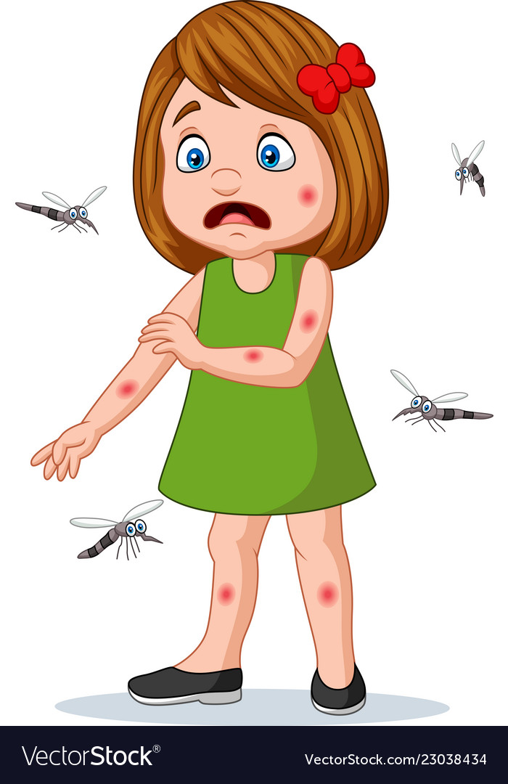

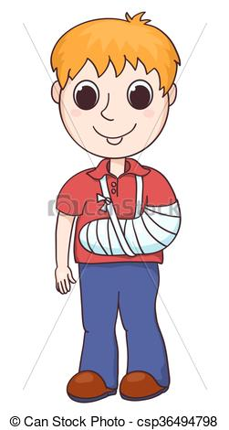



|  |  |
| --- | --- |
| headache | sore throat |
| backache | toothache |
| earache | broken arm |
| stomachache | cut |
| fever/  temperature | insect bite |
| flu/ cold | cough |
| asthma | diarrhea |
| vomit | runny nose |

|  |
| --- |
| A pain you have inside your stomach |
| A pain you feel inside your head |
| A pain you feel in your back |
| An illness that causes fever and headache |
| An arm that have one or more bone broken |
| An injury when the skin is cut with something sharp |
| A pain you feel in your ear |
| An illness which is similar to a fever. It often makes your muscles hurt. |
| An illness that force air out of your lungs |
| A pain you feel in your tooth |
| A painful injury caused by the insect’s stinger into skin |
| An illness that makes you have a liquid waste |
|  |
|  |
| A condition that blocks your airway and makes breathing difficult |
| A pain in the throat |
| A condition that blocks your airway and makes breathing difficult |
|  |
| A disease transmitted by a mosquito bite |
| A release of mucus from the nose, a symptom of the cold |