 | Demonstration School of Khon Kaen University (Mo Din Daeng)
 | Midterm Examination | Academic Year 2019
 | Fundamental English (ENG 31101) Grade 8
 | December 9, 2019 10.4 a.m-11.400 a.m
 | Instructor: Mrs Chutima Vongpralbu ,

Instructions :
There are 2 parts consisting 5 pages total: 60 points
Part 1: Multiple choice 15 items 15 points

Item 1-5: Choose the answer which relates to the picture.

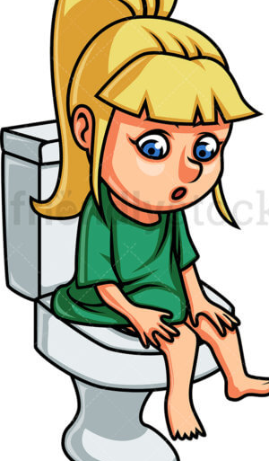
- a. Mary has a diarrhea. b. Mary has a vomit.
c. Mary has a cough. d. Mary has asthma.

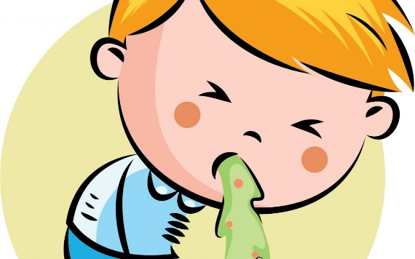
- a. Tom has a flu.
- b. Tom has temperature.
- c. Tom has a sore throat.
- d. Tom has a vomit.

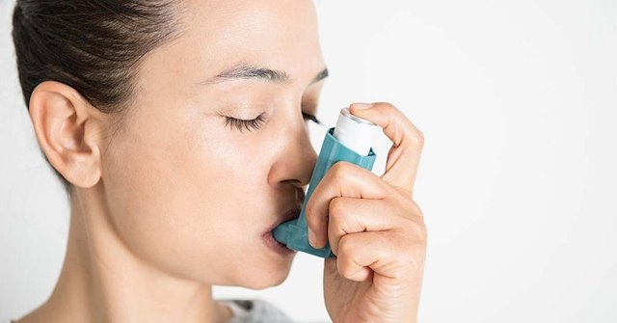
3. a Jane has a cut. b. Jane has insect bite.
c. Jane has asthma. d. Jane has a cold.

4. a. Mary has insect bite. b. Mary has a toothache.
c. Mary has a fever. d. Mary has a sore throat.

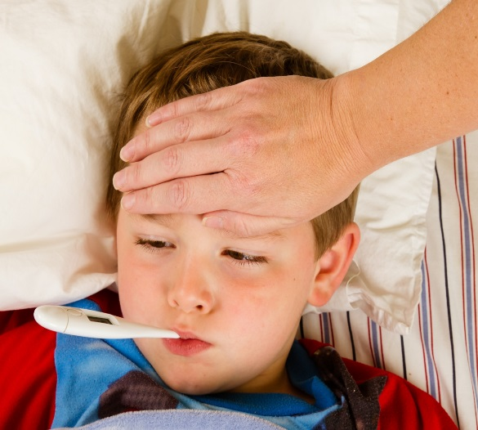
- a. Tom has a fever.
b. Tom has a cold.
c. Tom has a cough
d. Tom has a runny nose

Item 6-10: Choose the best answer to fill in the blank.

a. they feel very hot
b. they find it hard to breath
c. they have blood
d. they want to go to the toilet
e. they may have a cold

6. If someone has got flu______________.
7. If someone has got diarrhea____________.
8. If someone has got asthma_____________.
9. If someone has a cut ________________.
10. If someone has got a temperature____________________.

11. If you have a lot of spicy food and sour food you might have _________.
a. toothache b. headache c. runny nose d. diarrhea

12.A 5$ coin is ______ than a 10$ coin.

a. big b. bigger c. more bigger d. the biggest

13.Which sentence is not correct?

a. This book is more expensive than that one. b. Andy is as older as my sister.

c. She always gets up earlier than her husband. d. The Pacific is the largest ocean.

14.Which sentence is not correct?

a. My father is more healthy than my mother.

b. The exam was easier than I had expected.

c. New York is bigger than Bangkok.

d. Nico is the oldest girl in our class.

15.Which sentence is true?
- An elephant is bigger than a cat.

- b. English subject is the most hardest subject.

c. My school is more smaller than hers.

d. Gold is expensiver than silver.

Item 16- 19: Look at the table and answer the questions.

At the department store
Products | Camera | Television | Refrigerator | Mobile phone
Cost ($) | 72$ | 68$ | 59$ | 99$

16.According to the table, which product is the cheapest?

a. camera b. television c. refrigerator d. mobile phone

17.According to the table, which product is the most expensive?

a. camera b. television c. refrigerator d. mobile phon

18. Which sentence is true?
- If I buy 2 cameras, I pay less than buying 1 mobile phone.
- If I buy 1 mobile phone, I pay more than buying 2 refrigerators.
- If I buy 2 refrigerators, I pay more than buying 1 camera.
- If I buy 2 televisions, I pay less than buying 1 mobile phone.

19.Which sentence is true?
- Camera is cheaper than mobile phone, but it is more expensive than refrigerator.
- Television is cheaper than mobile phone and camera, so it is the cheapest product.
- Refrigerator is cheaper than camera, but it is more expensive than television.
- Television is cheaper than camera, but it is more expensive than 2 refrigerators.

Item 20-24: Choose the correct answer and mark X on the answer sheet.

(เลือกคำตอบที่ถูกต้องแล้วกา X ลงในกระดาษคำตอบ)
- richer b. elder c. the longest

d. the most expensive e. more intelligent

20. Nile River is______ river in the world.

21. Mark Zuckerberg earns 1 million dollars per second but Bill Gate earns 250 dollars,

so Mark Zuckerberg is_____ than Bill Gate.

22. My grandmother is 90 years old and my grandfather is 88 years old, so grandmother

is______ than grandfather.

23. The Debeers Centenary Diamond’s cost 100 million dollars, so it is______ diamond in

the world.

24. Albert Einstein is the scientist, so he is ______ than me.

PART II: Choose the most appropriate answer to fill in the blank.
I went on Holiday last year but it was a disaster! My hotel room was (25) ……………….. than the one in the photograph in the brochure. I think it was (26) ……………………. Room in the hotel. The weather was terrible, too. It was (27) ……………………… than in England. The beach near hotel was very dirty – it was (28) ………………………..of all the beaches on the island. The food was (29) ………………………… than I expected and I didn’t have enough money. One day I went shopping in a big department store and I broke a vase. It was (30) ………………… vase in the whole shop.
But (31) ……………………………. Thing of all was that I lost my passport and I couldn’t go back home. It was (32) …………………… holiday in my life.

25. a) bigger b) smaller
c) more comfortable d). more beautiful

26. a) bigger than b) smaller than
c) the biggest d) the smallest

27. a) better b) bad
c) colder d) more colder

28. a) cleaner b) the cleanest
c) dirties d) the dirtiest

29. a) more expensive b) the most expensive
c) more cheaper d) the cheapest

30. a) more expensive b) the most expensive
c) more cheaper d) the cheapest

31. a) the bad b) the worst
c) bad d) the best

32. a) the most wonderful b) the best
c) the most horrible d) the most beautiful

