Lesson Plan 5
Using SATIT KKU Creative Innovator Model
Foreign languages learning area
Demonstration School of KKU, Primary Level (Suksasart) Grade: 4 (Unit D IEC)
Module: 7 Helping out Topic: Recycling Project Allocated time: 5 periods
A lesson created by ______________________________________________ (PLC team)
Instructors: ______________________________ Date: ______ / ____ / _____
1. Concept:
Recycling is using something you don’t need anymore to make something new. We can recycle trash that are made of paper, plastic, metal and glass.
Creating a recycling project includes the following steps.
- Choosing the trash to recycle
- Describing the recycling project by using past simple tense verbs to tell what they did with the trash such as cleaned, cut, washed, decorated, wrapped, painted, glued, or dried.
- Presenting the recycling project using the following description pattern.
“It was an old ________________ (recyclable trash).
I _________, _________, and ___________ (past tense verbs).
Now, it’s a ________________ (new thing).”

2. Learning standards
Strand 1: Language for Communication
Standard F1.1: Understanding of and capacity to interpret what has been heard and read from various types of media, and ability to express opinions with proper reasoning
Indicator F1.1.3. Choose the pictures corresponding to the meanings of words, groups of words and sentences heard.
Indicator F1.1.4. Answer questions from listening to sentences, dialogues or simple tales with illustrations.
F1.3: Ability to present data, information, concepts and views about various matters through speaking and writing
Indicator F1.3.1. Speak to give data about themselves and matters around them. (Present the recycling project)
Strand 4: Language and relationship with community and the World
Standard F4.1: Ability to use foreign languages in various situations in school, community and society.
Indicator F4.1.1. Listen/speak in simple situations in the classroom.

3. Objectives: By the end of this class, the students will be able to:
1. pronounce and tell the meaning of the vocabulary and or pictures showed accurately.
2. make sentences to describe their recycling project correctly.
3. recycle the trash and present the recycling project correctly.
4. be environmentally friendly.

4. Contents:
1.1 Recycling is using something you don’t need any more to make something new.
1.2 Types of recyclable trash
1.2.1 Paper such as newspaper, paper bag, magazine or boxes
1.2.2 Plastic such as bottle, glass, or cup
1.2.3 Metal such as can
1.2.4 Glass such as jar or bottle
1.3 Past tense verbs (for describing the recycled product) include cleaned, cut, washed, decorated, wrapped, painted, glued, or dried
Example of sentences
- I washed the jar and decorated it.
- I wrapped the box and wrapped it.
1.4 Structures for presenting a recycled product
“It was an old ________________ (recyclable trash).
I _________, _________, and ___________ (past tense verbs).
Now, it’s a ________________ (new thing).”
Example of description
This was an old jar of jam. I washed it and decorated it. Now, it’s a pencil holder.

5. Learning procedures
(Period 1)
การเชื่อมโยงความรู้เดิมกับความรู้ใหม่

5.1 Connecting Previous and New Knowledge

- Play a YouTube video titled Whale dies after swallowing 80 plastic bags for 1.20 minutes and pause the video.
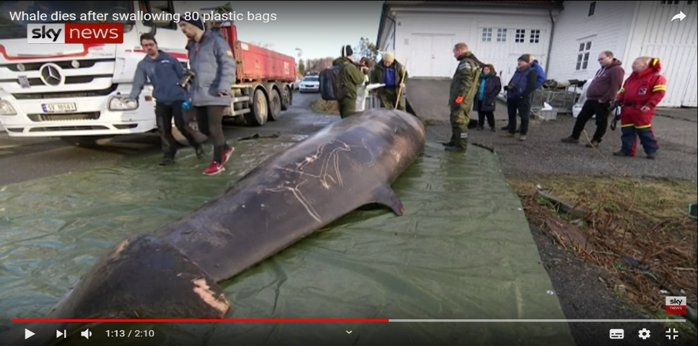

- Discuss with the students about what happened with the whale and ask them the following questions.
  - Why was it died? [It ate a lot of plastic bags.]
  - Who dropped the plastic bags into the ocean? [Humans.]
  - What else did humans throw into the oceans, the rivers, or on the floor? [Students name various kinds of trash.]
  - Ask students to name the type of the trash that they have learnt from the previous classes. [Paper, plastic, metal and glass.]
- Bring a pile of old containers and get the students to divide into two groups and play the game called recycling races.
  - Spread the empty bottles, boxes, cartons, cans, and other trash all around the classroom.
  - Put the trash cans labelled four types of trash in front of the class.
  - Teacher blows the whistle and students in the team take turns picking up as many trash as they can.
  - After that, each team separate the trash into the correct trash can and report to the class.
  - The team that has collected the most trash and has placed them to the correct trash can wins the game.
- Students work on Get Smart workbook, page 63, activity 2 by finding 10 things they can recycle and write the name of the trash next to each picture.

(Period 2-3)
5.2 Cognitive Conflict and Doing Learning Task
การกระตุ้นให้เกิดความขัดแย้งทางปัญญา/ความสงสัย และปฏิบัติภารกิจการเรียนรู้

- Play the same video continuing from 1.20 till the end of the video. The students watch what the woman in the video suggested how to reduce plastics in Thailand. [Selling plastic bags in 7/11 shop or other shops.]
- Students do the learning task after watching the video by answering the following questions.
  - How can you reduce the number of the trash? [Guided answer: reuse or recycle the trash]
  - What can we recycle and how can we recycle? Give some examples.

5.3 Exploring Independently and Constructing Knowledge and Exploring Various Ideas
การสร้างและแสวงหาความรู้ด้วยตนเองและขยายแนวคิดที่หลากหลาย

- Students look at the example of the recycled product shown in Get Smart student book, page 69. They listen to the audio and read the description aloud.

- Discuss the following topics.
  - What was recycled? [An old jar of jam.]
  - How did she recycle it? [She washed it and decorated it.]
  - What is it now? [Now, it’s a pencil holder.]
  - Is the recycled product useful? [Yes, it is.]
- Students use their books, dictionaries, phones, tablets or the computers in the classroom to look up for the verbs that can be used for describing how people can recycle things. Then, put them on the board and changed the verbs into past tense forms e.g. cleaned, cut, washed, decorated, wrapped, painted, glued, or dried
- Students visit YouTube site/application and explore the recycling ideas and discuss what product will be useful and will not become trash again after it has been recycled.
5.4 Idea Sharing and Constructing Group conclusion
การสร้างความเข้าใจของตนเองและกลุ่มโดยการสะท้อนความคิดและ สรุปองค์ความรู้

- Divide students into six groups.
- Students in each group pick different old containers that they used in the recycling races game.
- Students discuss how they can recycle the chosen container and what they can do with it. They can brainstorm their ideas and write them down in a form of mind mapping, diagram, chart, table or pictures.
- They can display their ideas via various sources: PowerPoint, Note pad, or paper.
- Students in each group present their ideas to the class and give suggestions.
- Students work on Get Smart workbook, page 63, activity 1 by putting items into recycling machine and write what they were before and what they are now.

(Period 4-5)
5.5 Creating Product and Innovation
การสร้างผลิตภัณฑ์และนวัตกรรม

- Have students bring recyclable trash and recycle it.
- Students write a draft description of their recycled product.
- Students get the draft revised by their peer and their teacher.
- Students write the final draft of the description and practice to present their product in front of the class.
การสร้างแนวคิดการเป็นผู้ประกอบการ
5.6 Creating How to be an entrepreneur
- Students comment about their friends’ recycling project and discuss choose the products that can be adjusted and sold in the market in the garden activity or choose they products that will be useful for their local community or school.

6. Instructional media/ Learning materials:
1. Computer / Projector
2. Get Smart 4 CD
3. Get Smart 4 Student Book, page 69, activity 1-3
4. Get Smart 4 Workbook, page 63, activity 1-2
5. YouTube video entitled Whale dies after swallowing 80 plastic bags retrieved from https://www.youtube.com/watch?v=1LI3XhcefZg
6. Old containers
7. Four trash cans
8. Phones/tablets
9. Paper
10. Dictionaries
7. Assessment and evaluation
Objectives | Methods | Tools | Criteria
1. Pronounce and tell the meaning of the vocabulary and or pictures showed accurately. | - Observe the students | - Learning activities | 70 percent of the students can pronounce the vocabulary correctly.
2. make sentences to describe their recycling project correctly. | - Observe the students  - Check the students’ workbook | - Recycling races game  - Get Smart 4 Workbook, page 63, activity 1-2  - Recycling project assessment form | 70 percent of the students can
3. Recycle the trash and present the recycled product in English correctly. | - Assess the recycling project | - Recycling project assessment form | 70 percent of the students can reach the good criteria of the assessment form.
4. Be environmentally friendly. | - Assess the recycling project | - Recycling project assessment form | 70 percent of the student use materials that are environmentally friendly.

8. The instructor’s reflections
8.1 Reflections on learning arrangement
__________________________________________________________________________
__________________________________________________________________________
__________________________________________________________________________
__________________________________________________________________________
8.2 Problems and obstacles
__________________________________________________________________________
__________________________________________________________________________
__________________________________________________________________________
__________________________________________________________________________
8.3 Solutions and suggestions
__________________________________________________________________________
__________________________________________________________________________
__________________________________________________________________________
__________________________________________________________________________
___________________________
(_______________________________)
The instructor
Date: ____/____/____

